**DEPLOYMENT OF WORDPRESS ENVIRONMENT**

**Steps to Perform:**

1. Establish configuration management master connectivity with WordPress server
2. Validate connectivity from master to slave machine
3. Prepare IaC scripts to install WordPress and its dependent components
4. Execute scripts to perform installation of complete WordPress environment
5. Validate installation using the public IP of VM by accessing WordPress application

**STEP-1: Establish configuration management master connectivity with WordPress server**

1. Do these in the configuration management master server as well as node, i.e., wordpress server:

sudo apt update (updates the machine)

sudo su (switch to root user)

sudo adduser ansible (create an ansible user)

enter password and other credentials for ansible user

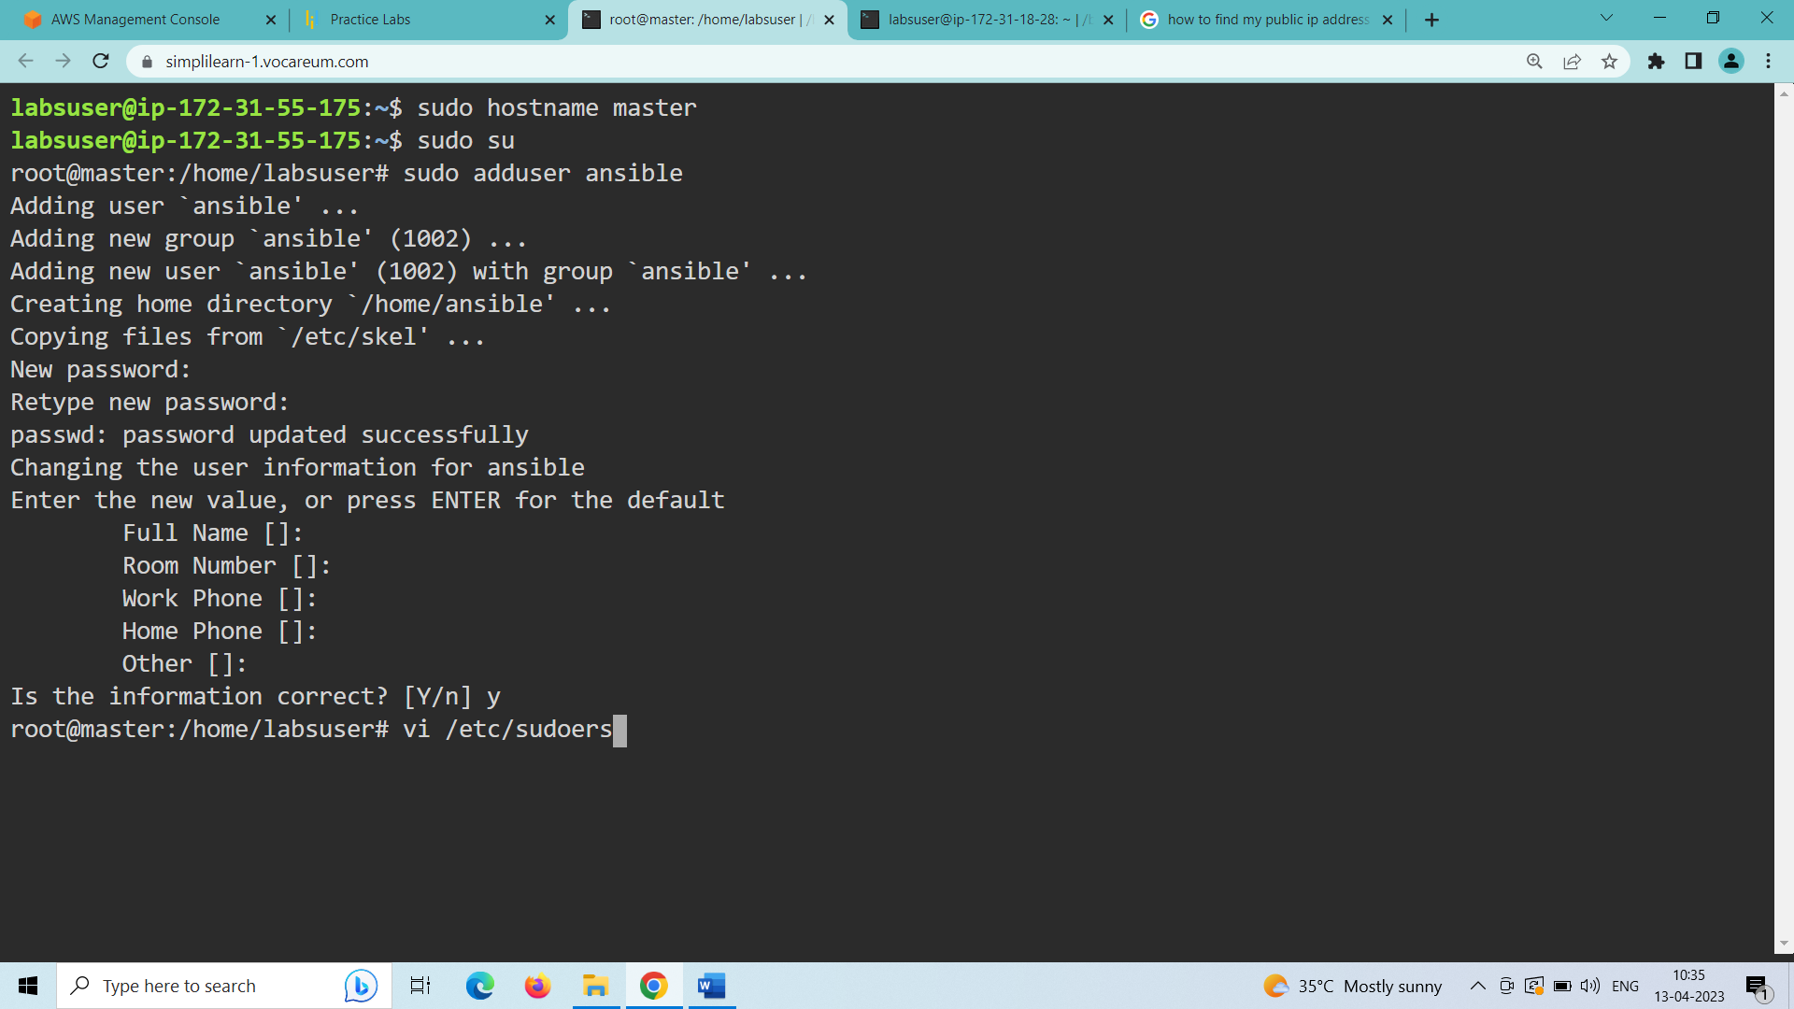

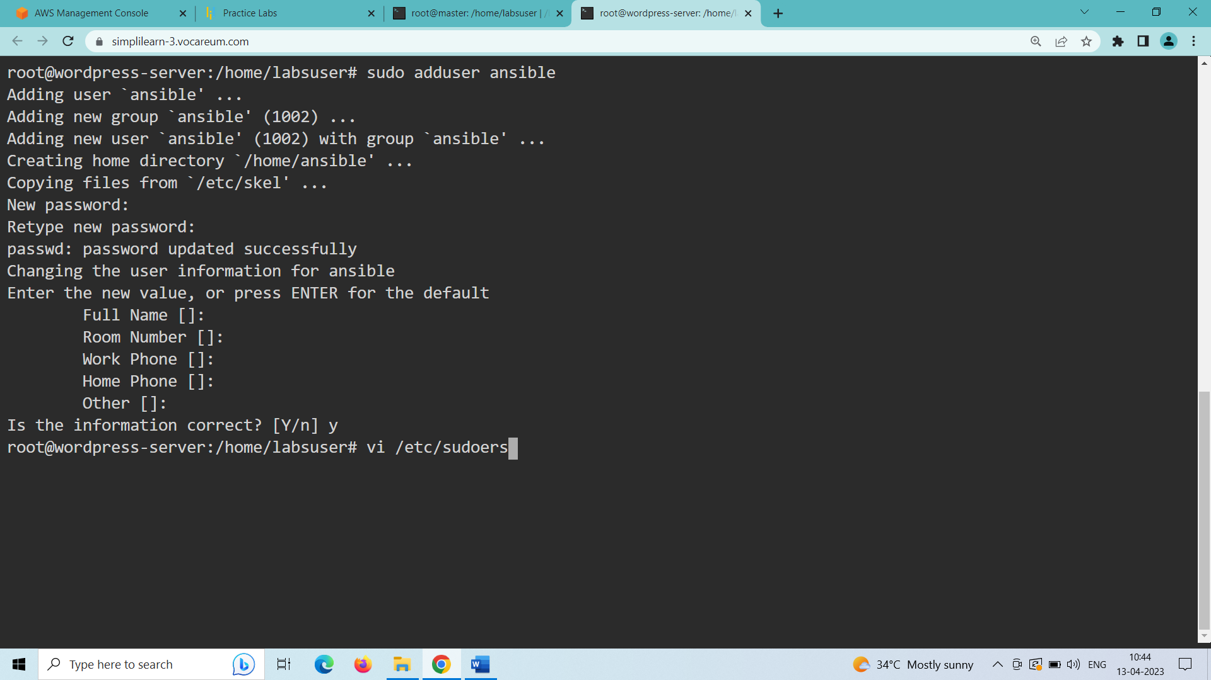

vi /etc/sudoers

(inside the sudoers file in line 45 under user privilege specification add this line to permit passwordless super user rights to ansible user)

ansible ALL=(ALL:ALL) NOPASSWD: ALL

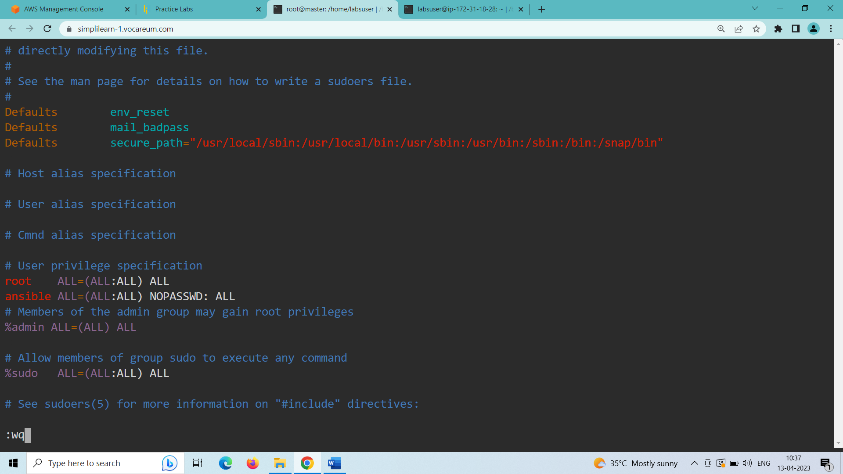

vi /etc/ssh/sshd_config

(inside the sshd_config file in line 57 change PasswordAuthentication from no to yes)

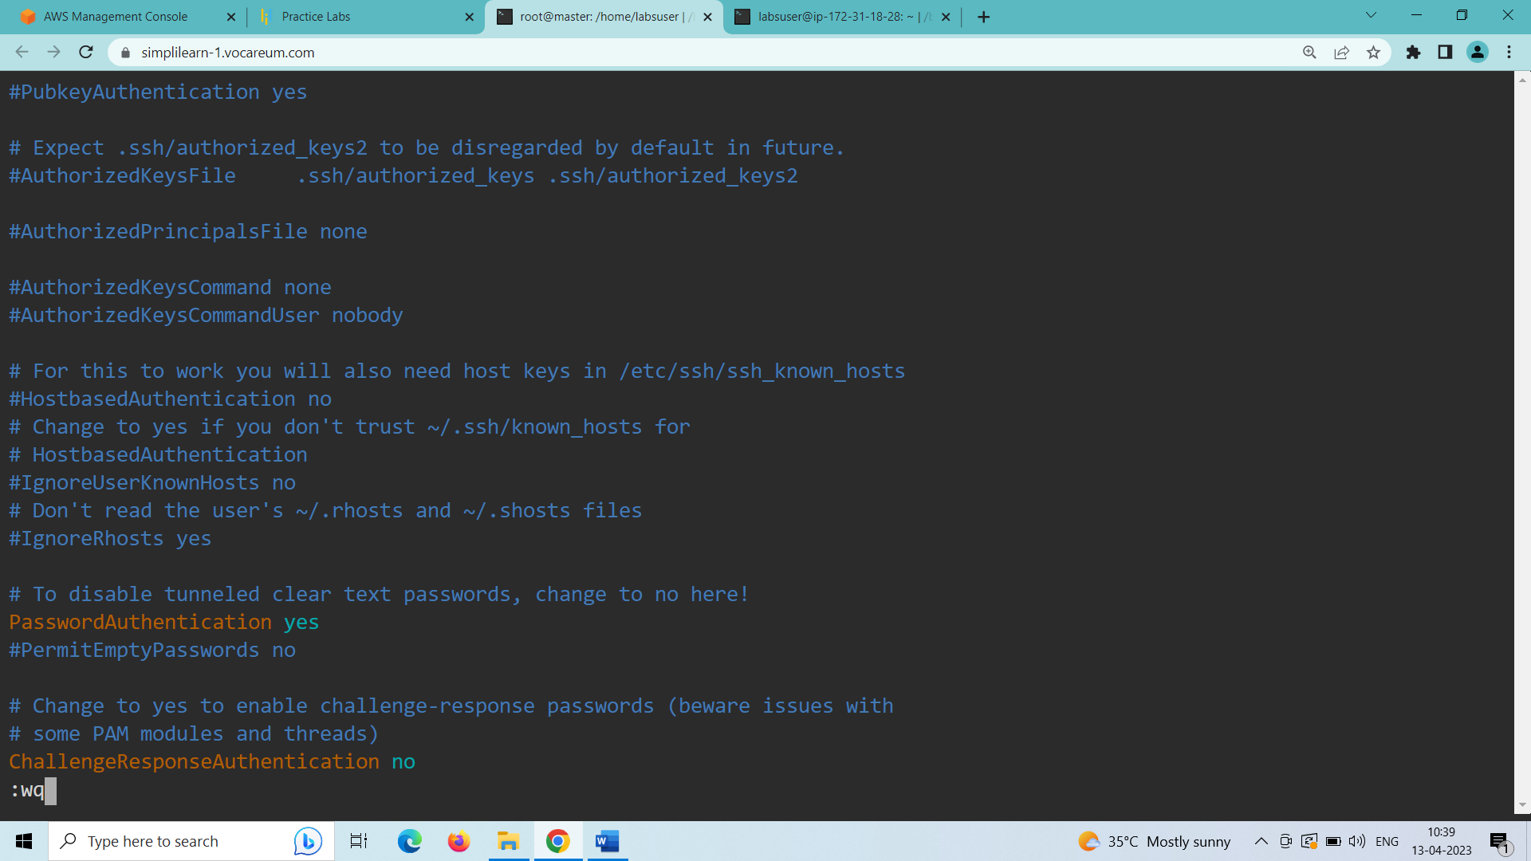

systemctl restart sshd (to restart sshd)

1. Only in the master server:

switch to ansible user and generate keys for ssh login to wordpress server

su – ansible (switches to ansible user)

ssh-keygen (generates public key for ansible user)

cat .ssh/id_rsa.pub (copy this key into authorized_keys folder inside the .ssh folder in wordpress server)

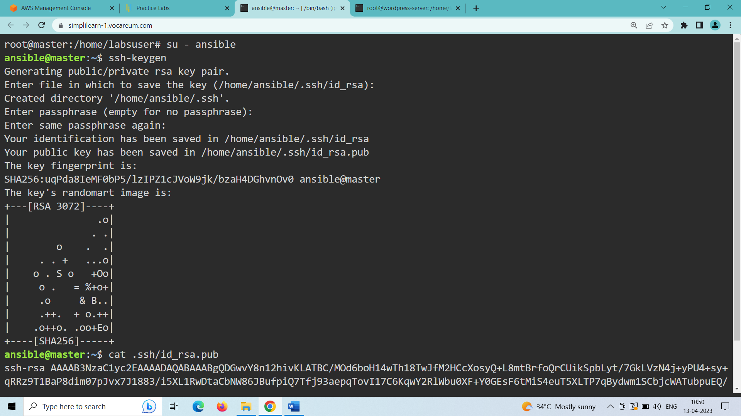

1. Inside the wordpress server:

su – ansible (switch to ansible user)

ssh-keygen (to create a .ssh folder in ansible home directory)

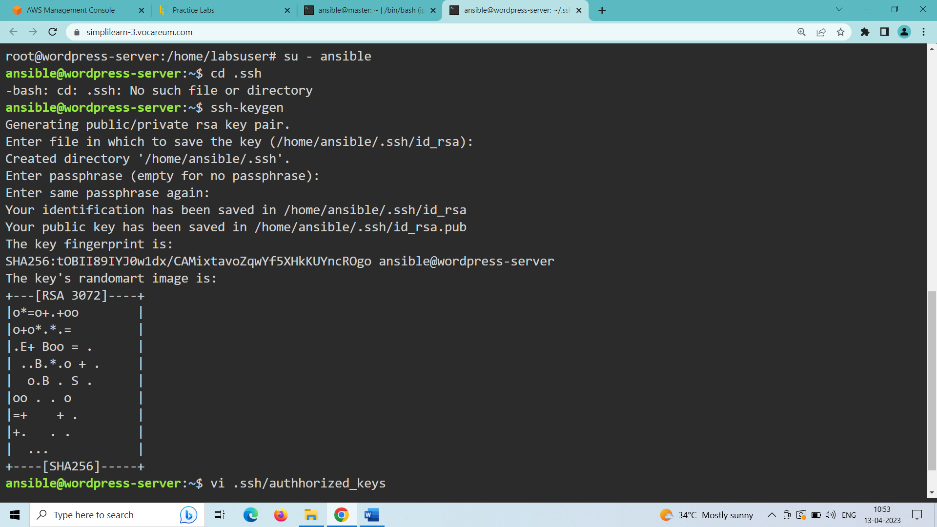

vi .ssh/authorized_keys (paste the key generated from master server to wordpress server in this folder)

**STEP-2: Validate connectivity from master to slave machine**

Inside the master server:

(check the connectivity from master to wordpress server)

ssh <private-ip-of-wp-server> (login to the wordpress server)

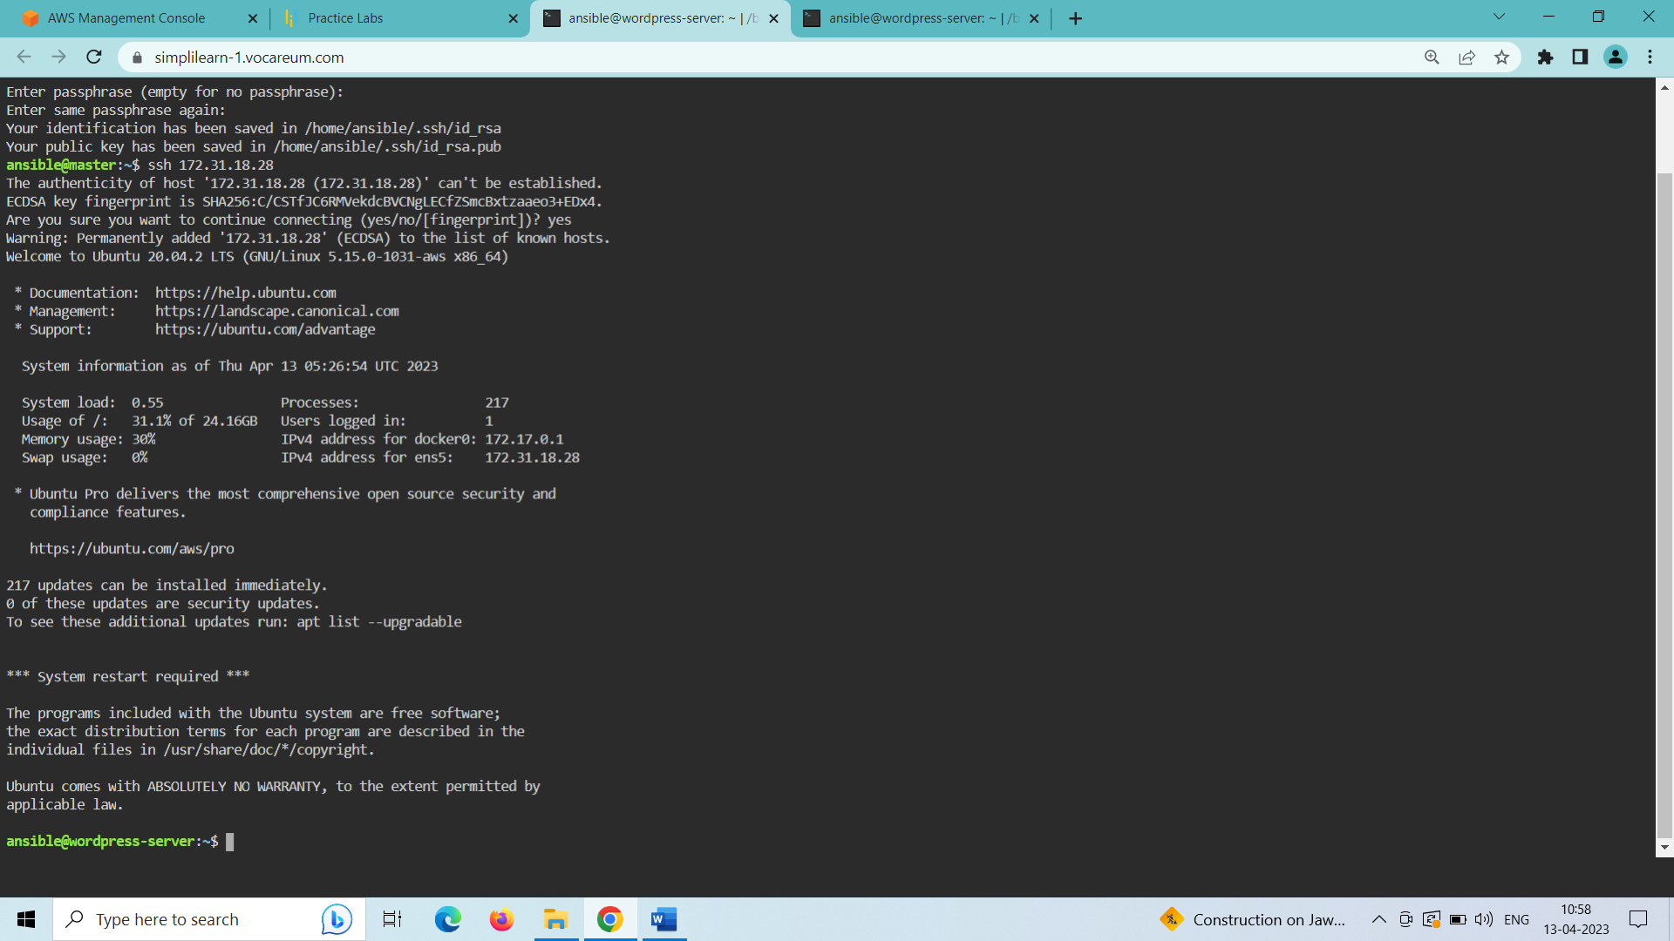

exit (to exit the connection from wordpress server and login back to master server)

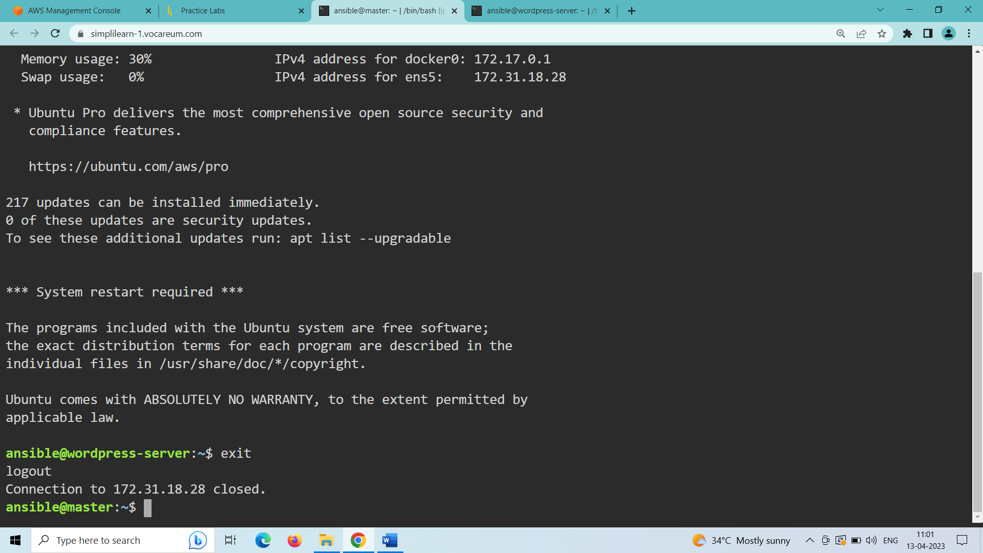

1. Install ansible and add ansible repositories:

sudo apt-add-repository ppa:ansible/ansible (installs ansible repositories)

sudo apt update (updates the machine)

sudo apt install ansible -y (installs ansible)

sudo vi /etc/ansible/hosts (inside the hosts file add the private ip of the wordpress server under wpserver host-group)

[wpserver]

<private-ip-of-wp-server>

(exit the file by using :wq)

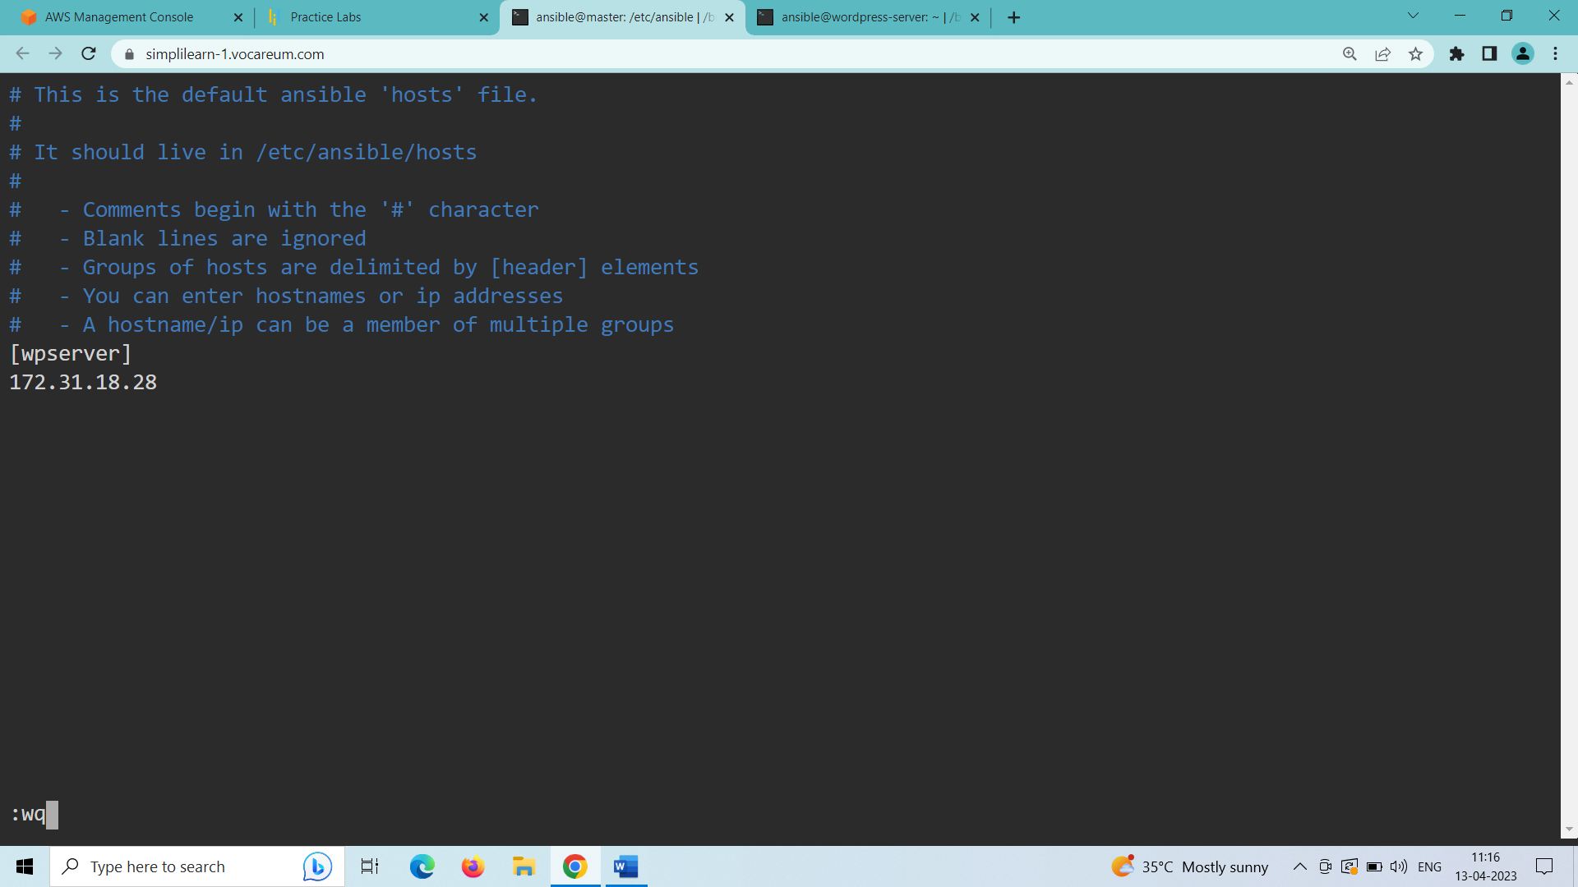

1. Check the ping from master to slave machine using ansible adhoc command:

ansible -m ping wpserver

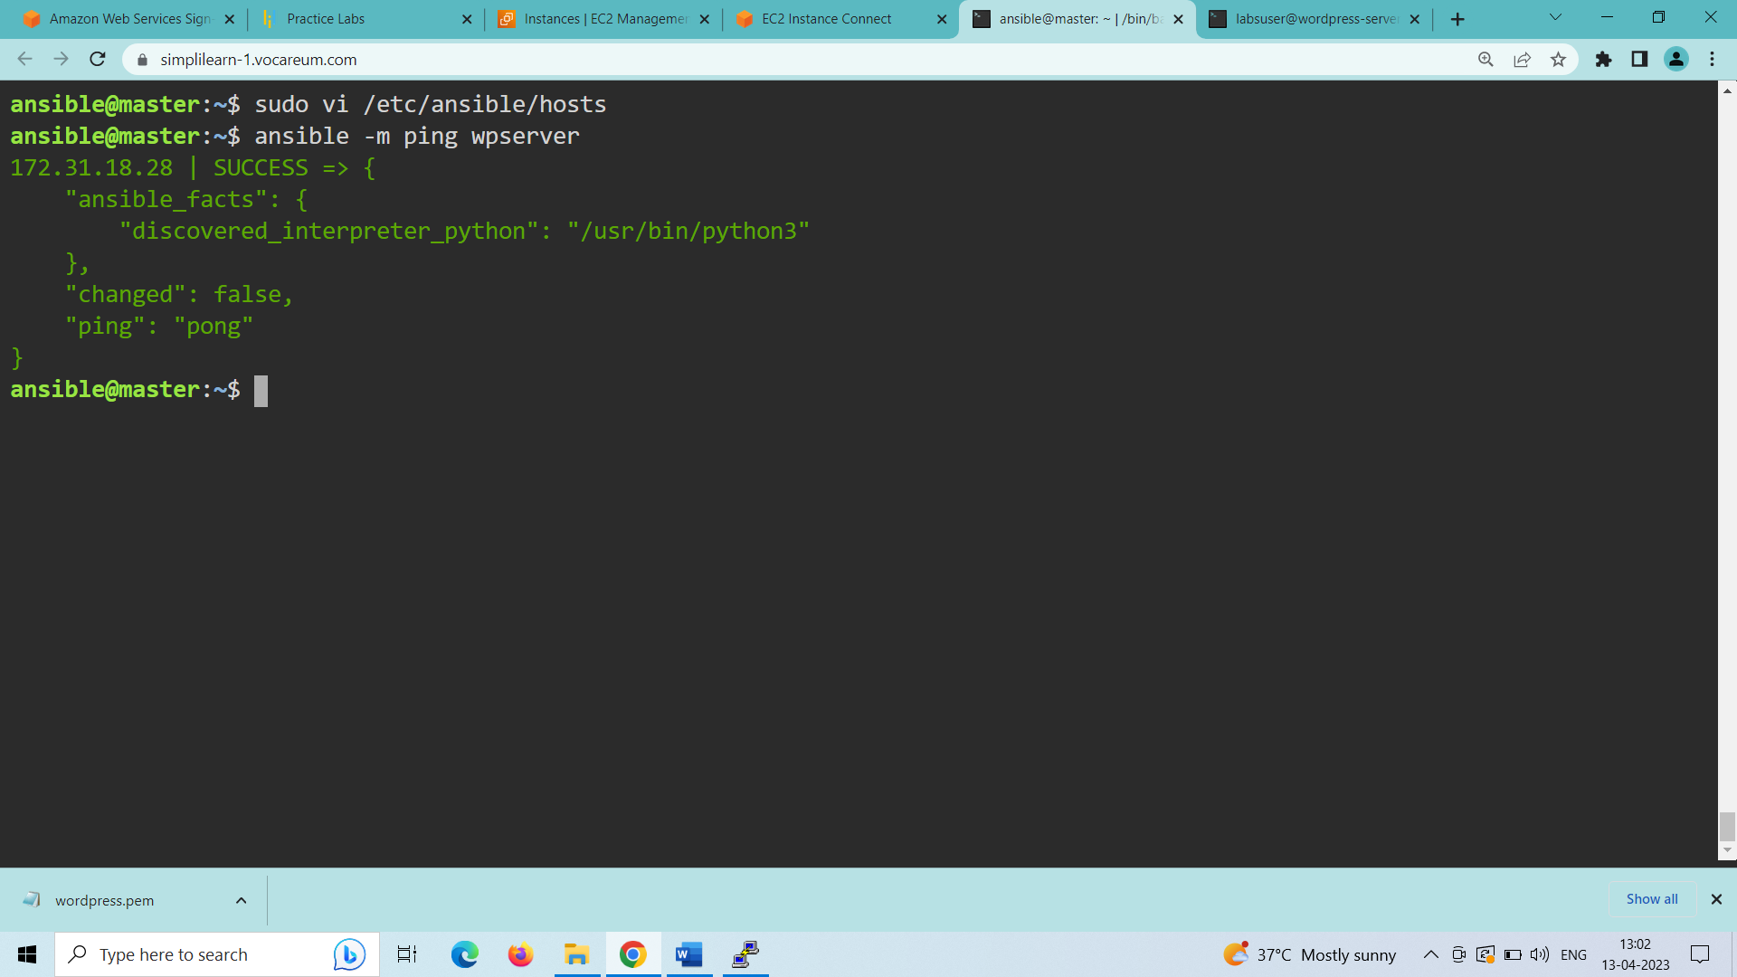

Ping successful from master to wordpress server node.

**STEP-3: Prepare IaC scripts to install WordPress and its dependent components**

1. Create a wordpress working directory:

mkdir wordpress (creates a working directory named wordpress)

cd wordpress (enter into the wordpress directory)

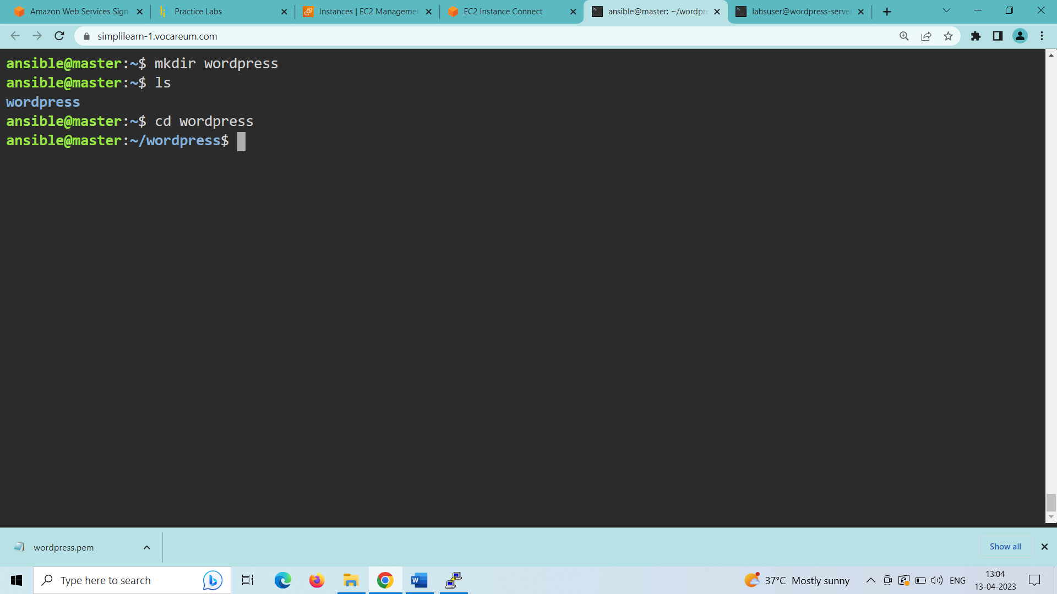

Create and write a playbook inside this folder to install WordPress and its dependent components.

1. Create a playbook to write the script to install Wordpress and it dependent components and configure each of the components:

vi playbook.yml (creates a playbook named playbook.yml)

#####inside the playbook:

---

- hosts: wpserver

become: true

vars_files:

- vars/default.yml

tasks:

- name: Install prerequisites

apt: name=aptitude update_cache=yes state=latest force_apt_get=yes

tags: [ system ]

- name: Install dependent packages

apt: name={{ item }} update_cache=yes state=latest

loop: [ 'apache2', 'mysql-server', 'python3-pymysql', 'php', 'php-mysql', 'libapache2-mod-php' ]

tags: [ system ]

- name: Install PHP Extensions

apt: name={{ item }} update_cache=yes state=latest

loop: "{{ php_modules }}"

tags: [ system ]

# Apache Configuration

- name: Create document root

file:

path: "/var/www/{{ http_host }}"

state: directory

owner: "www-data"

group: "www-data"

mode: '0755'

tags: [ apache ]

- name: Set up Apache VirtualHost

template:

src: "files/apache.conf.j2"

dest: "/etc/apache2/sites-available/{{ http_conf }}"

notify: Reload Apache

tags: [ apache ]

- name: Enable rewrite module

shell: /usr/sbin/a2enmod rewrite

notify: Reload Apache

tags: [ apache ]

- name: Enable new site

shell: /usr/sbin/a2ensite {{ http_conf }}

notify: Reload Apache

tags: [ apache ]

- name: Disable default Apache site

shell: /usr/sbin/a2dissite 000-default.conf

notify: Restart Apache

tags: [ apache ]

# MySQL Configuration

- name: Set the root password

mysql_user:

name: root

password: "{{ mysql_root_password }}"

login_unix_socket: /var/run/mysqld/mysqld.sock

tags: [ mysql, mysql-root ]

- name: Remove all anonymous user accounts

mysql_user:

name: ''

host_all: yes

state: absent

login_user: root

login_password: "{{ mysql_root_password }}"

tags: [ mysql ]

- name: Remove the MySQL test database

mysql_db:

name: test

state: absent

login_user: root

login_password: "{{ mysql_root_password }}"

tags: [ mysql ]

- name: Creates database for WordPress

mysql_db:

name: "{{ mysql_db }}"

state: present

login_user: root

login_password: "{{ mysql_root_password }}"

tags: [ mysql ]

- name: Create MySQL user for WordPress

mysql_user:

name: "{{ mysql_user }}"

password: "{{ mysql_password }}"

priv: "{{ mysql_db }}.*:ALL"

state: present

login_user: root

login_password: "{{ mysql_root_password }}"

tags: [ mysql ]

# UFW Configuration

- name: "UFW - Allow HTTP on port {{ http_port }}"

ufw:

rule: allow

port: "{{ http_port }}"

proto: tcp

tags: [ system ]

# WordPress Configuration

- name: Download and unpack latest WordPress

unarchive:

src: https://wordpress.org/latest.tar.gz

dest: "/var/www/{{ http_host }}"

remote_src: yes

creates: "/var/www/{{ http_host }}/wordpress"

tags: [ wordpress ]

- name: Set ownership

file:

path: "/var/www/{{ http_host }}"

state: directory

recurse: yes

owner: www-data

group: www-data

tags: [ wordpress ]

- name: Set permissions for directories

shell: "/usr/bin/find /var/www/{{ http_host }}/wordpress/ -type d -exec chmod 750 {} \\;"

tags: [ wordpress ]

- name: Set permissions for files

shell: "/usr/bin/find /var/www/{{ http_host }}/wordpress/ -type f -exec chmod 640 {} \\;"

tags: [ wordpress ]

- name: Set up wp-config

template:

src: "files/wp-config.php.j2"

dest: "/var/www/{{ http_host }}/wordpress/wp-config.php"

tags: [ wordpress ]

handlers:

- name: Reload Apache

service:

name: apache2

state: reloaded

- name: Restart Apache

service:

name: apache2

state: restarted

(save and quit the file using :wq)

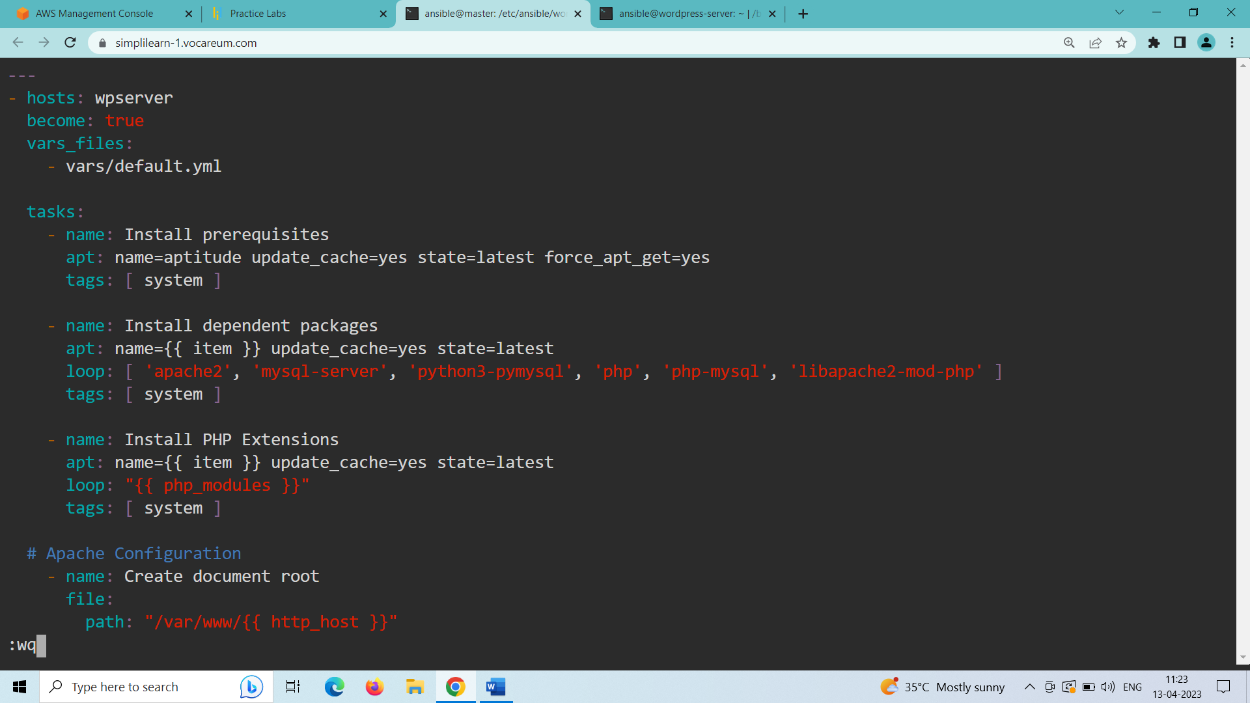

PLAYBOOK EXPLANATION:

* The script in the playbook performs installation of prerequisites first and the dependent packages required for wordpress site.
* Performs installation of Php Extensions.
* Performs Apache Configuration.
* Performs MySQL Configuration.
* Performs Firewall configuration to allow connection to Wordpress site.
* Performs WordPress Configuration.
* Executes Handlers to reload and restart apache2.

1. Create a directory to add jinja templates for standard use whenever a new requirement or client comes in:

mkdir files (creates a directory named files inside the wordpress directory)

cd files (enter into files directory)

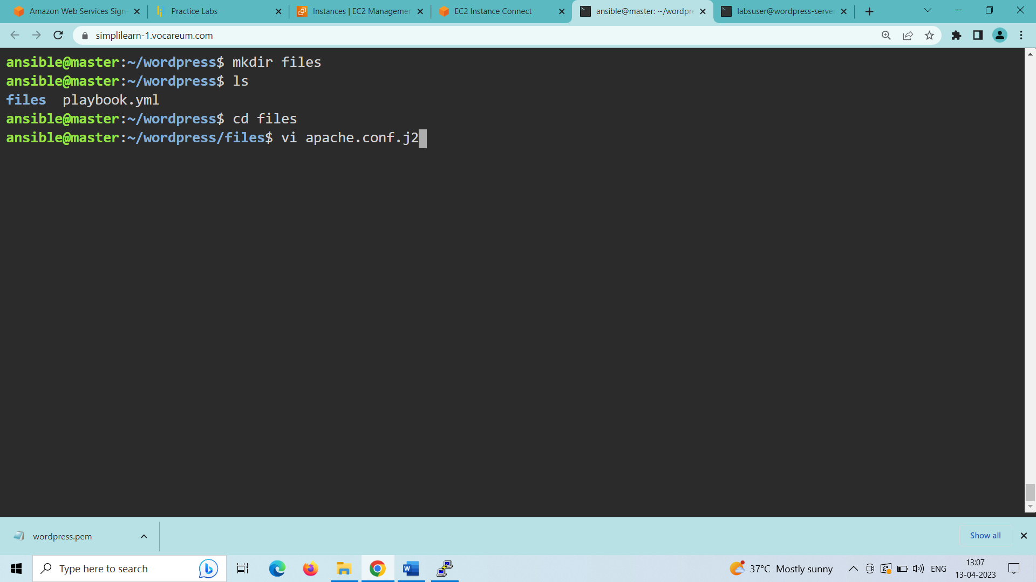

1. vi apache.conf.j2 (creates an apache jinja template file)

#####inside the apache.conf.j2 file:

<VirtualHost *:{{ http_port }}>

ServerAdmin webmaster@localhost

ServerName {{ http_host }}

ServerAlias www.{{ http_host }}

DocumentRoot /var/www/{{ http_host }}/wordpress

ErrorLog ${APACHE_LOG_DIR}/error.log

CustomLog ${APACHE_LOG_DIR}/access.log combined

<Directory /var/www/{{ http_host }}>

Options -Indexes

AllowOverride All

</Directory>

<IfModule mod_dir.c>

DirectoryIndex index.php index.html index.cgi index.pl index.xhtml index.htm

</IfModule>

</VirtualHost>

(save and quit the file using :wq)

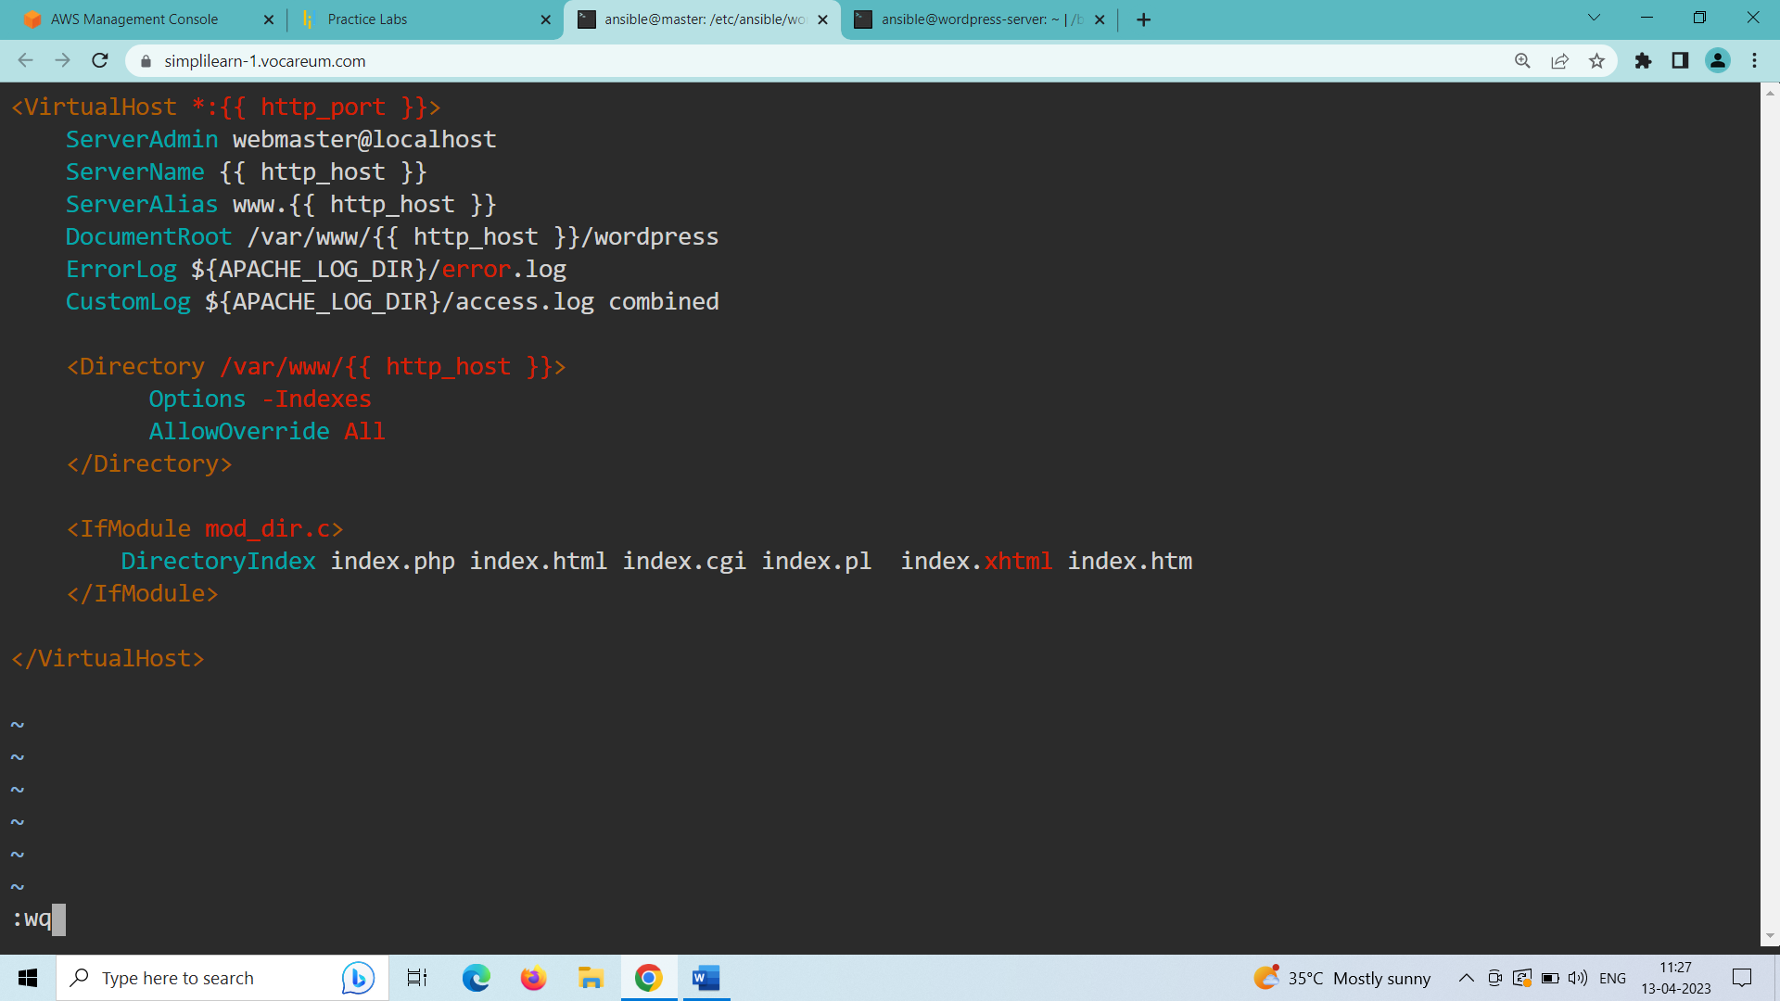

1. vi wp-config.php.j2 (creates a wordpress configuration jinja template file)

#####inside the wp-config.php.j2 file:

<?php

/**

* The base configuration for WordPress

*

* The wp-config.php creation script uses this file during the

* installation. You don't have to use the web site, you can

* copy this file to "wp-config.php" and fill in the values.

*

* This file contains the following configurations:

*

* * MySQL settings

* * Secret keys

* * Database table prefix

* * ABSPATH

*

* @link https://codex.wordpress.org/Editing_wp-config.php

*

* @package WordPress

*/

// ** MySQL settings - You can get this info from your web host ** //

/** The name of the database for WordPress */

define( 'DB_NAME', '{{ mysql_db }}' );

/** MySQL database username */

define( 'DB_USER', '{{ mysql_user }}' );

/** MySQL database password */

define( 'DB_PASSWORD', '{{ mysql_password }}' );

/** MySQL hostname */

define( 'DB_HOST', 'localhost' );

/** Database Charset to use in creating database tables. */

define( 'DB_CHARSET', 'utf8' );

/** The Database Collate type. Don't change this if in doubt. */

define( 'DB_COLLATE', '' );

/** Filesystem access **/

define('FS_METHOD', 'direct');

/**#@+

* Authentication Unique Keys and Salts.

*

* Change these to different unique phrases!

* You can generate these using the {@link https://api.wordpress.org/secret-key/1.1/salt/ WordPress.org secret-key service}

* You can change these at any point in time to invalidate all existing cookies. This will force all users to have to log in again.

*

* @since 2.6.0

*/

define( 'AUTH_KEY', '{{ lookup('password', '/dev/null chars=ascii_letters length=64') }}' );

define( 'SECURE_AUTH_KEY', '{{ lookup('password', '/dev/null chars=ascii_letters length=64') }}' );

define( 'LOGGED_IN_KEY', '{{ lookup('password', '/dev/null chars=ascii_letters length=64') }}' );

define( 'NONCE_KEY', '{{ lookup('password', '/dev/null chars=ascii_letters length=64') }}' );

define( 'AUTH_SALT', '{{ lookup('password', '/dev/null chars=ascii_letters length=64') }}' );

define( 'SECURE_AUTH_SALT', '{{ lookup('password', '/dev/null chars=ascii_letters length=64') }}' );

define( 'LOGGED_IN_SALT', '{{ lookup('password', '/dev/null chars=ascii_letters length=64') }}' );

define( 'NONCE_SALT', '{{ lookup('password', '/dev/null chars=ascii_letters length=64') }}' );

/**#@-*/

/**

* WordPress Database Table prefix.

*

* You can have multiple installations in one database if you give each

* a unique prefix. Only numbers, letters, and underscores please!

*/

$table_prefix = 'wp_';

/**

* For developers: WordPress debugging mode.

*

* Change this to true to enable the display of notices during development.

* It is strongly recommended that plugin and theme developers use WP_DEBUG

* in their development environments.

*

* For information on other constants that can be used for debugging,

* visit the Codex.

*

* @link https://codex.wordpress.org/Debugging_in_WordPress

*/

define( 'WP_DEBUG', false );

/* That's all, stop editing! Happy publishing. */

/** Absolute path to the WordPress directory. */

if ( ! defined( 'ABSPATH' ) ) {

define( 'ABSPATH', dirname( __FILE__ ) . '/' );

}

/** Sets up WordPress vars and included files. */

require_once( ABSPATH . 'wp-settings.php' );

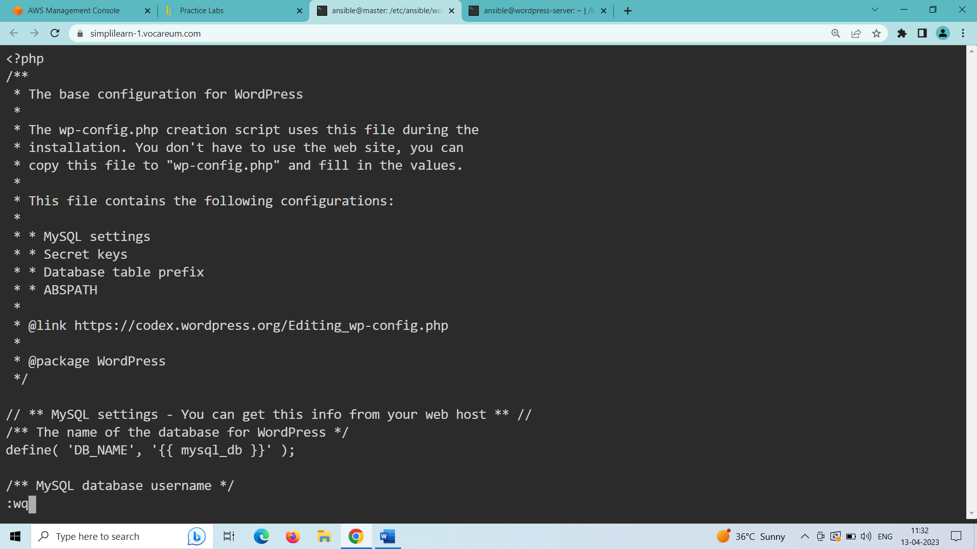

(save and quit the file using :wq)

cd .. (to enter into the wordpress directory)

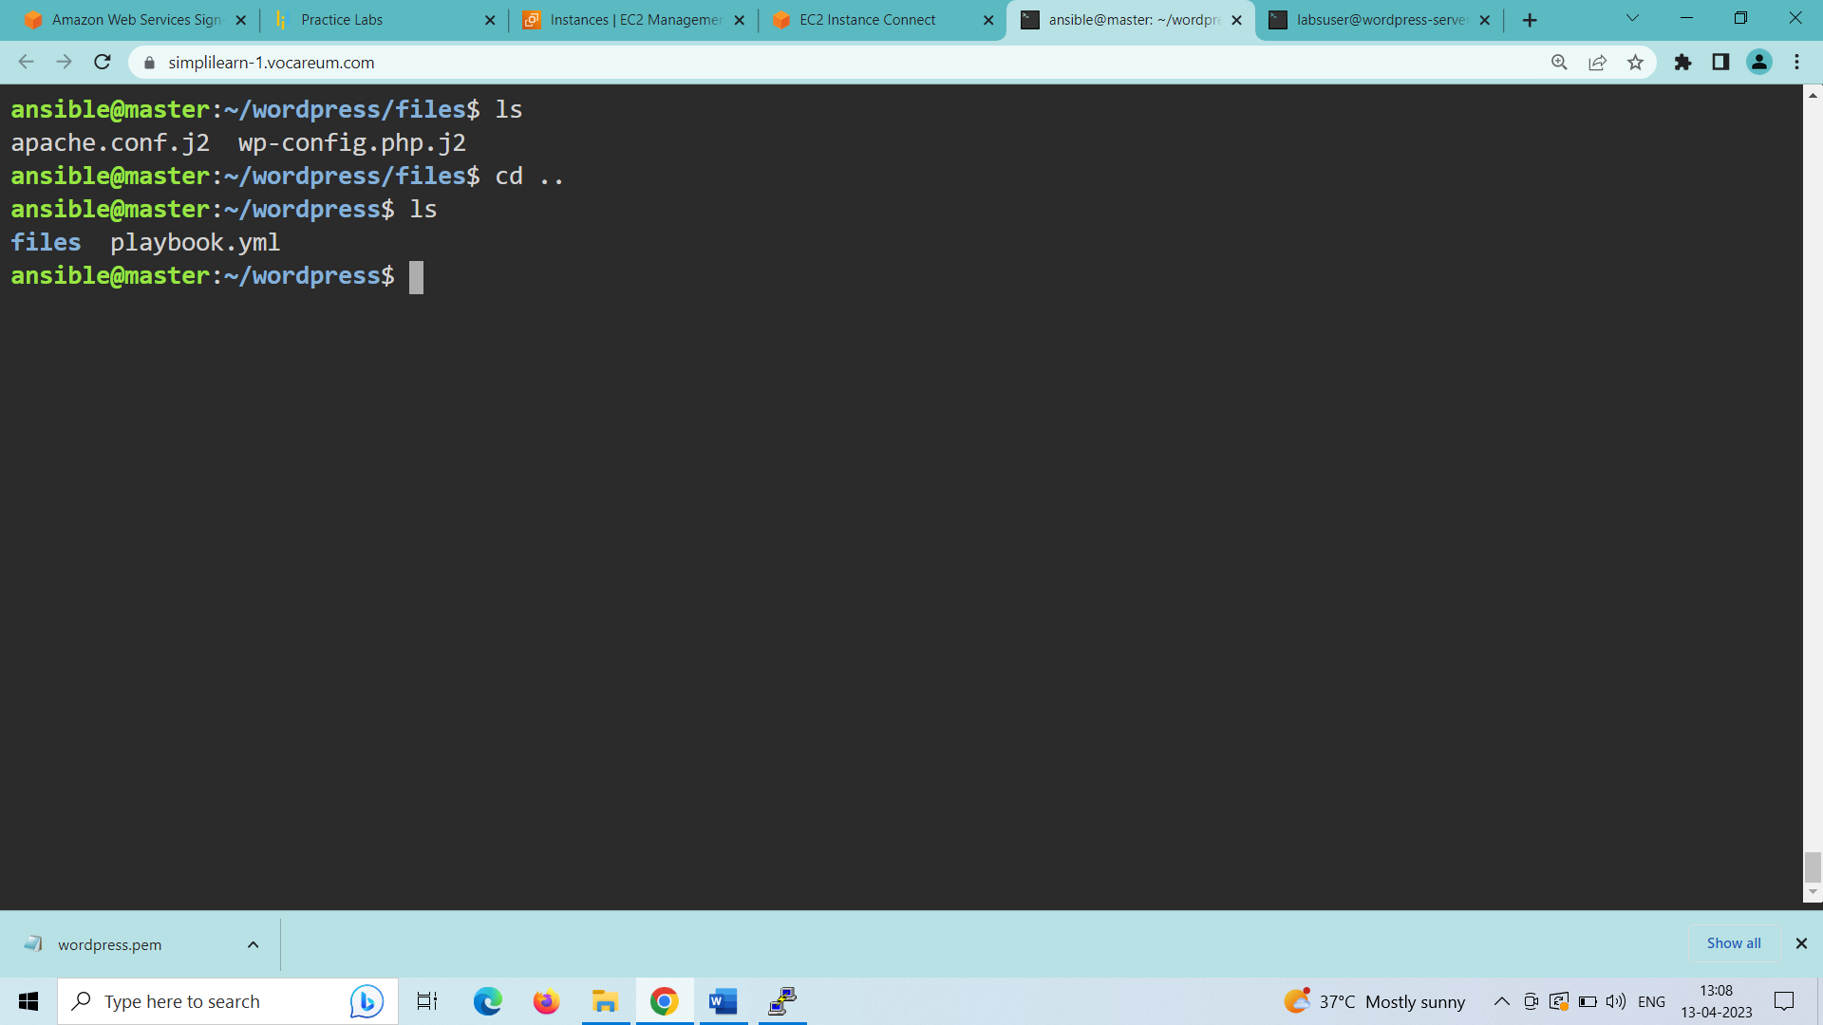

1. Create a directory named vars in the wordpress working directory to store all the variables for the playbook:

mkdir vars (creates a directory named vars)

cd vars (enter into the vars directory)

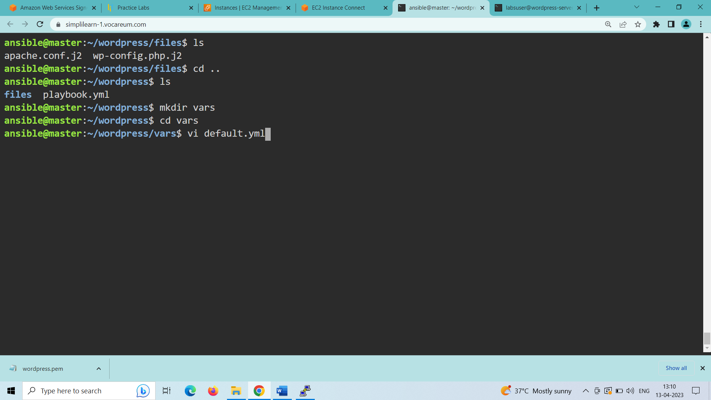

1. vi default.yml (creates a file named default.yml)

#####inside the default.yml file:

---

#System Settings

php_modules: [ 'php-curl', 'php-gd', 'php-mbstring', 'php-xml', 'php-xmlrpc', 'php-soap', 'php-intl', 'php-zip' ]

#MySQL Settings

mysql_root_password: "root_password"

mysql_db: "wordpress"

mysql_user: "ansible"

mysql_password: "password"

#HTTP Settings

http_host: "172.31.18.28”

http_conf: "wp-site.conf"

http_port: "80"

(save and quit the file using :wq)

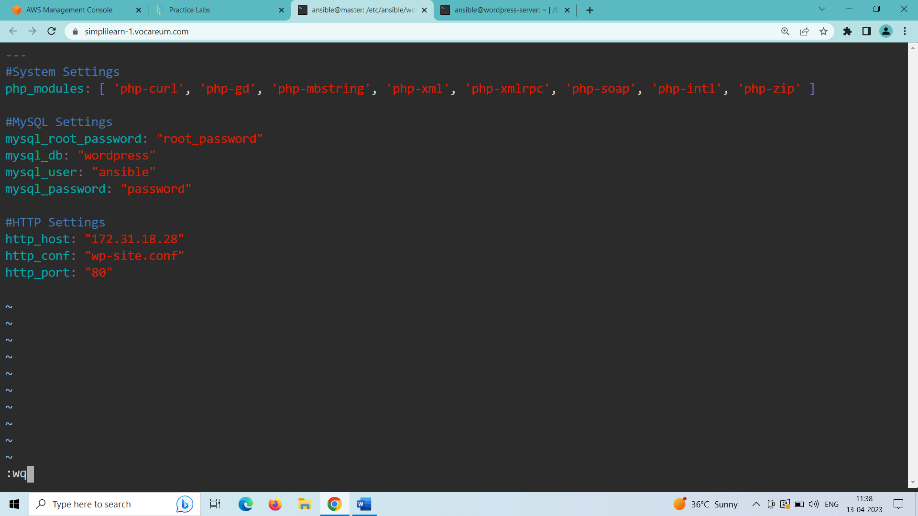

cd .. (to enter into the wordpress directory)

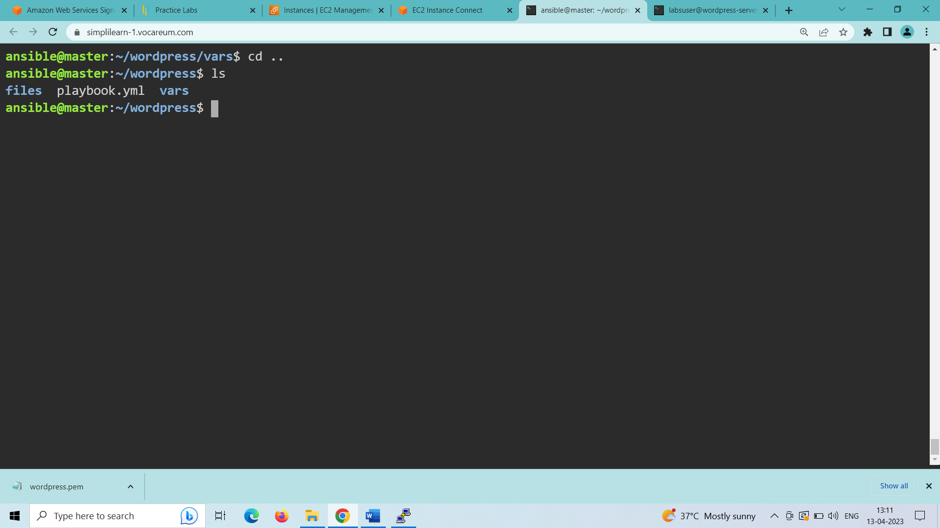

Change the template files and variable files as per the requirement of the client.

**STEP-4: Execute scripts to perform installation of complete WordPress environment**

1. ansible-playbook playbook.yml (to run the created playbook named playbook.yml)

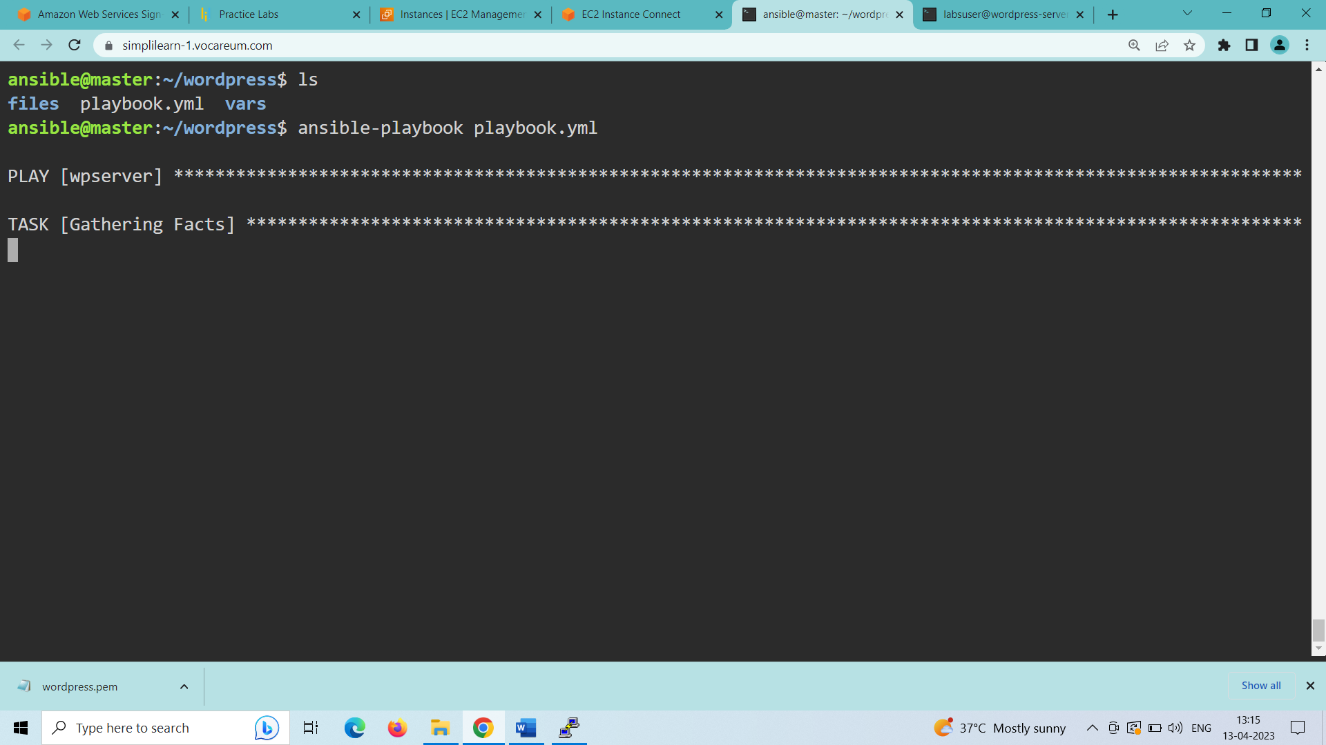

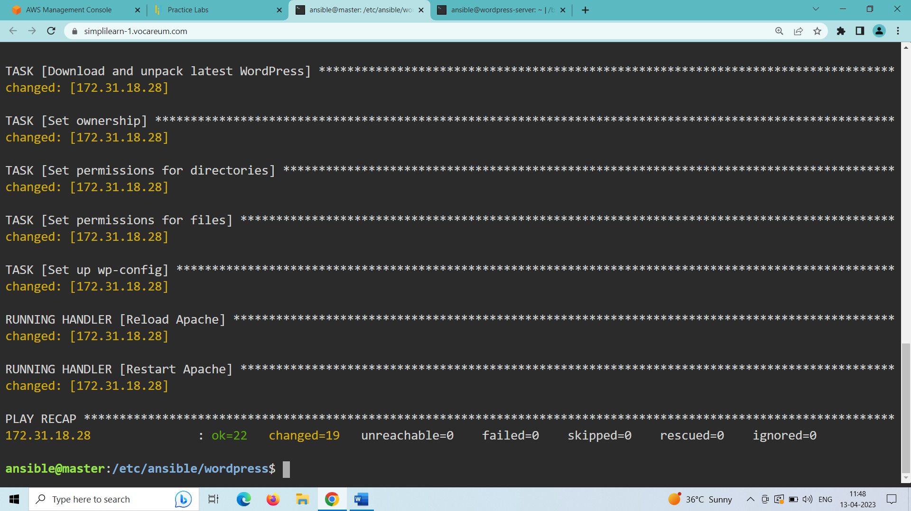

(playbook is executed successfully)

**STEP-5: Validate installation using the public IP of VM by accessing WordPress application**

1. To know the public ip of your wordpress server go to terminal of wordpress server and type the following command:

curl ifconfig.me (shows the public ip of wordpress)

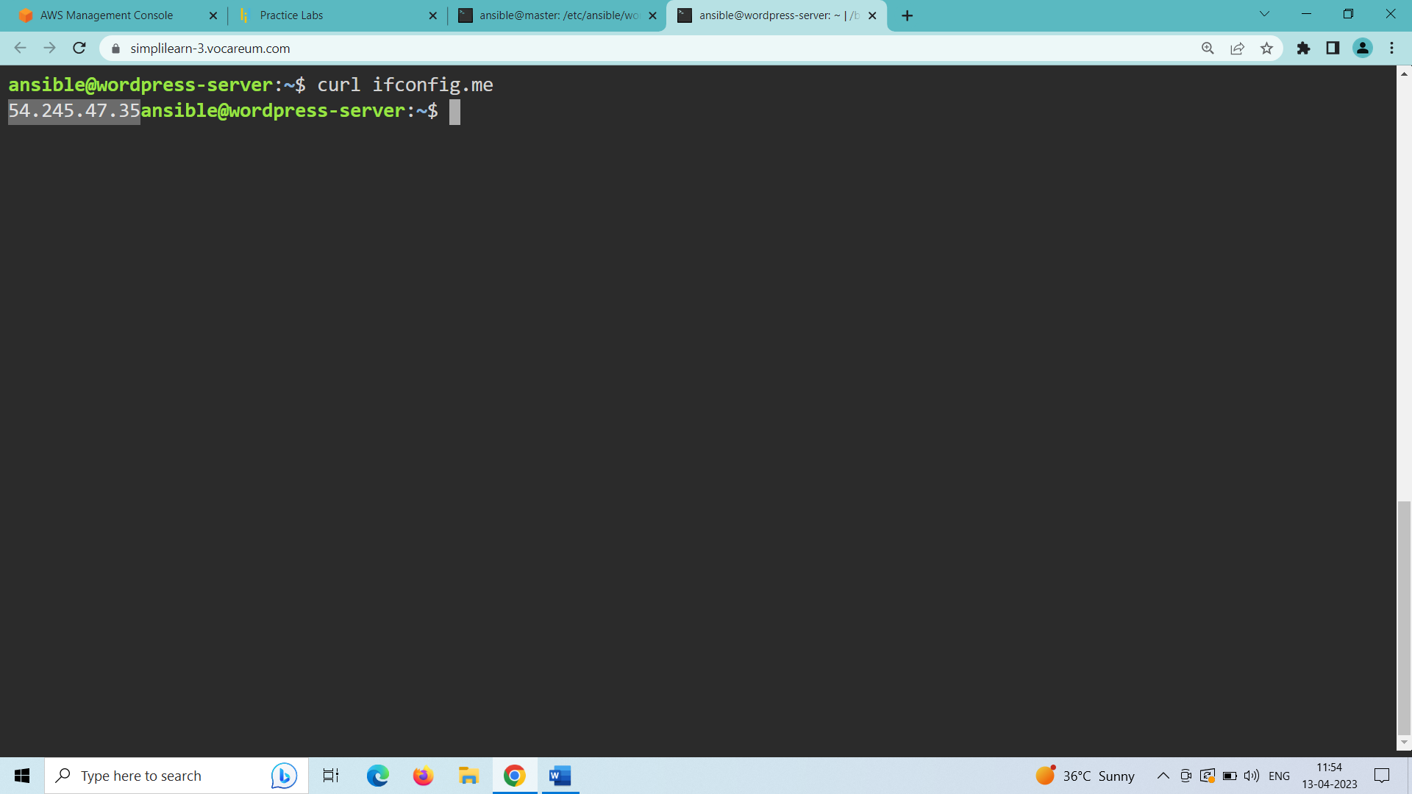

1. Open web browser in your machine and type the following in the address bar:

<http://54.245.47.35:80>

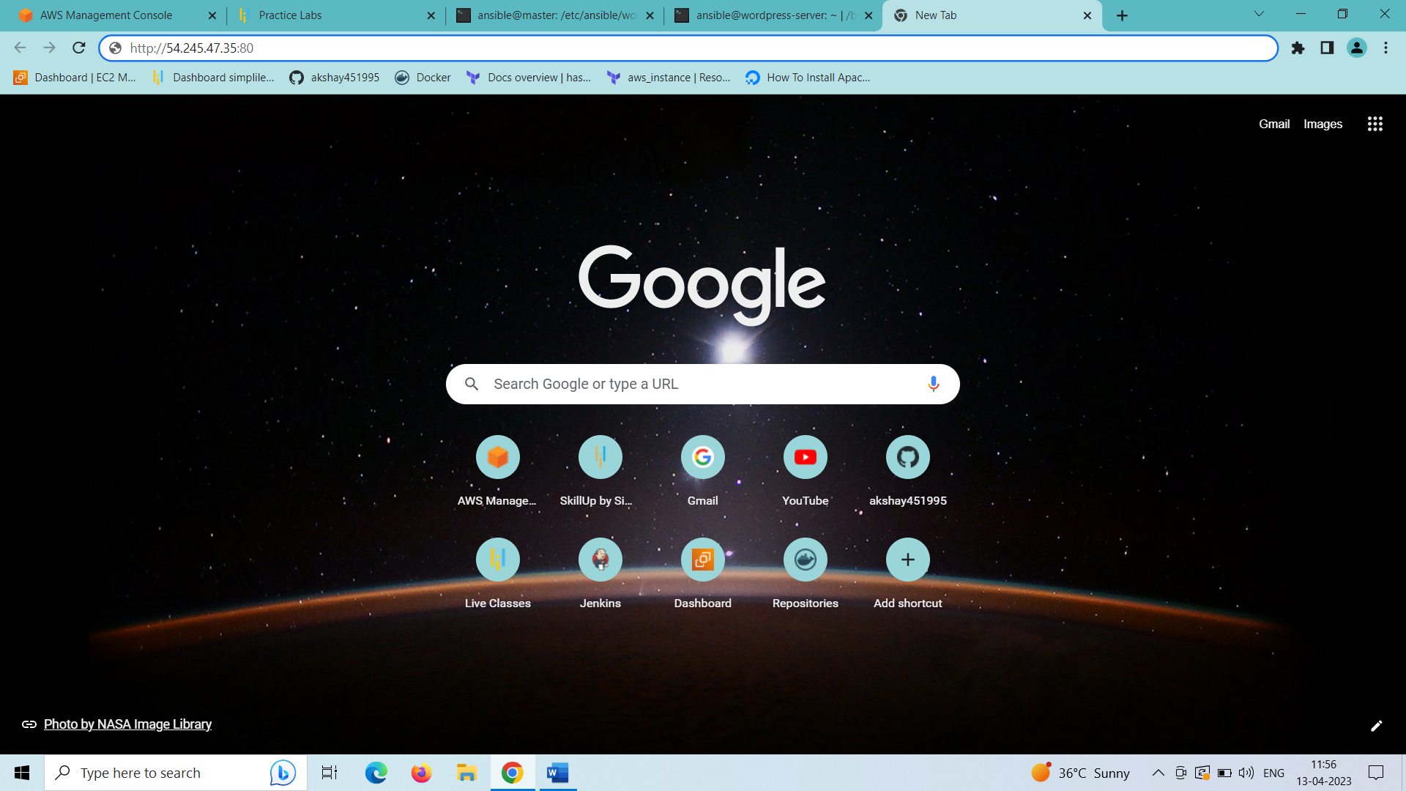

Wordpress site is not opening in the configuration management lab server even though all the dependencies and wordpress environment was successfully established on the wordpress server. Maybe due to some firewall issue in the lab server.

When I have done the same steps using aws lab it worked. Here is the result I got:

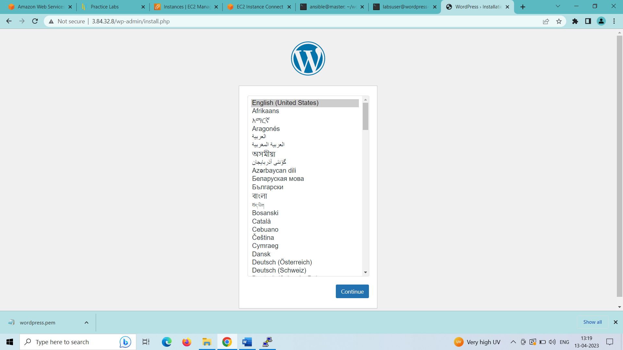

Wordpress language selection and login page is opened: enter your credentials and click on install wordpress.

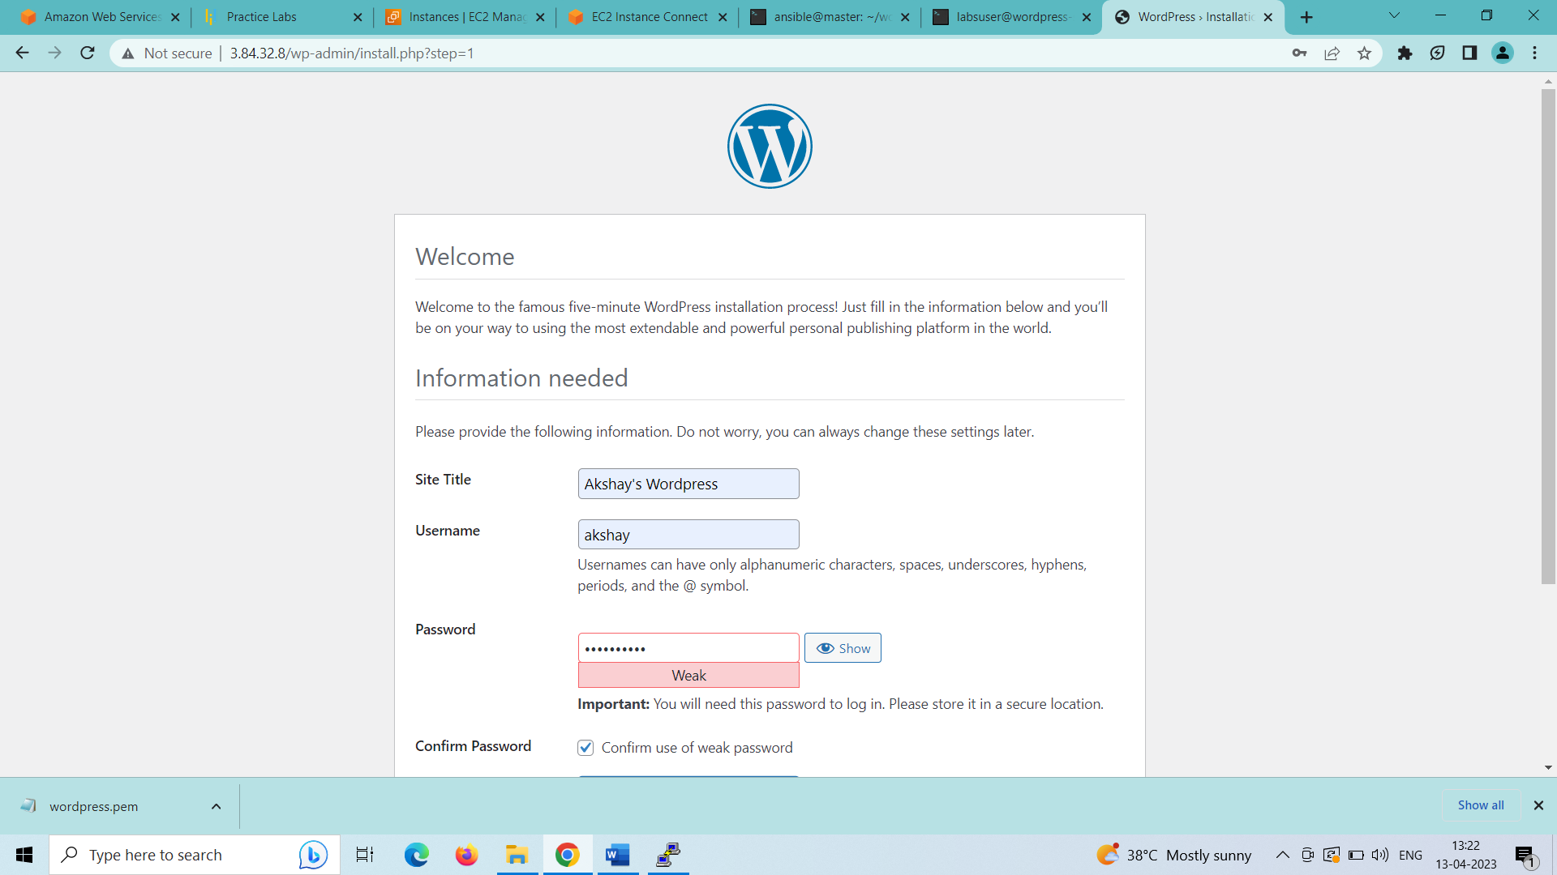

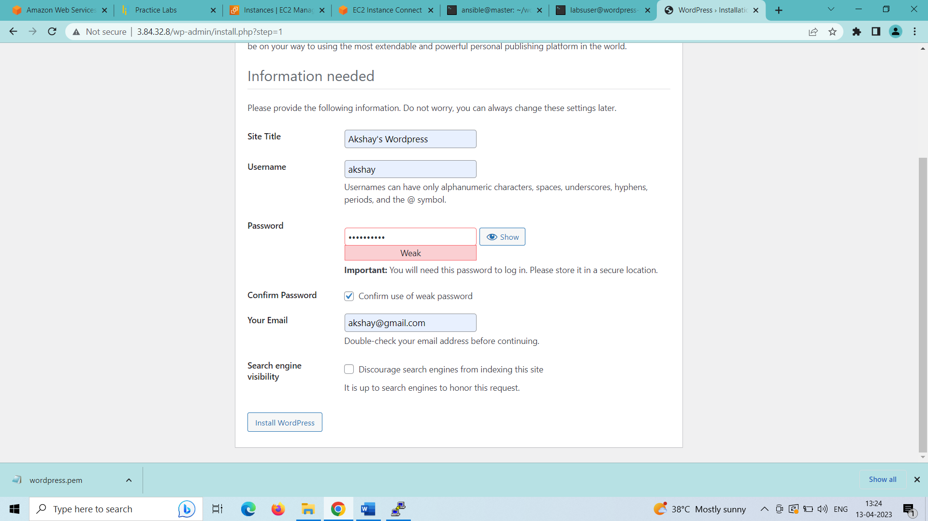

Now login to your account with your credentials and you will reach the dashboard of the wordpress site.

